Project Objective

To develop a comprehensive credit card weekly dashboard that provides real-time insights into key performance metrics and trends, enabling stakeholders to monitor and analyze credit card operations effectively.

Credit Card Dashboard

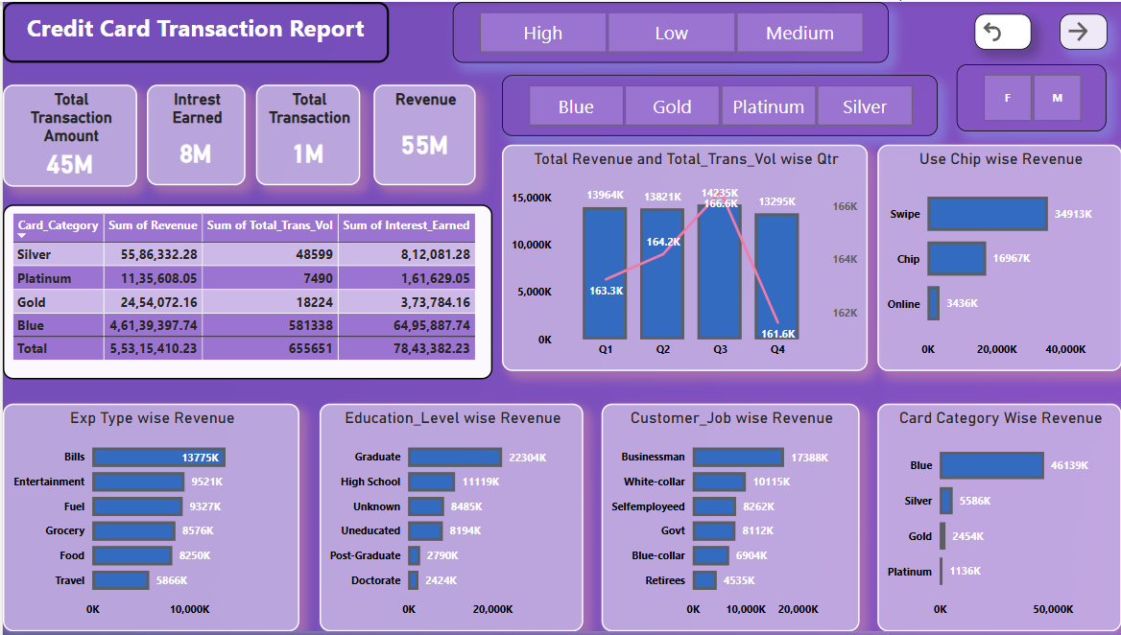

Insights

1) Blue Card is the top-performing card across all metrics.
2) Q3 is the best quarter for both revenue and volume.
3) Bills, Entertainment, and Fuel are major spend categories.
4) Revenue is higher from Graduates and Businessmen.
5) Swipe-based payments generate the highest revenue.

Customer Dashboard

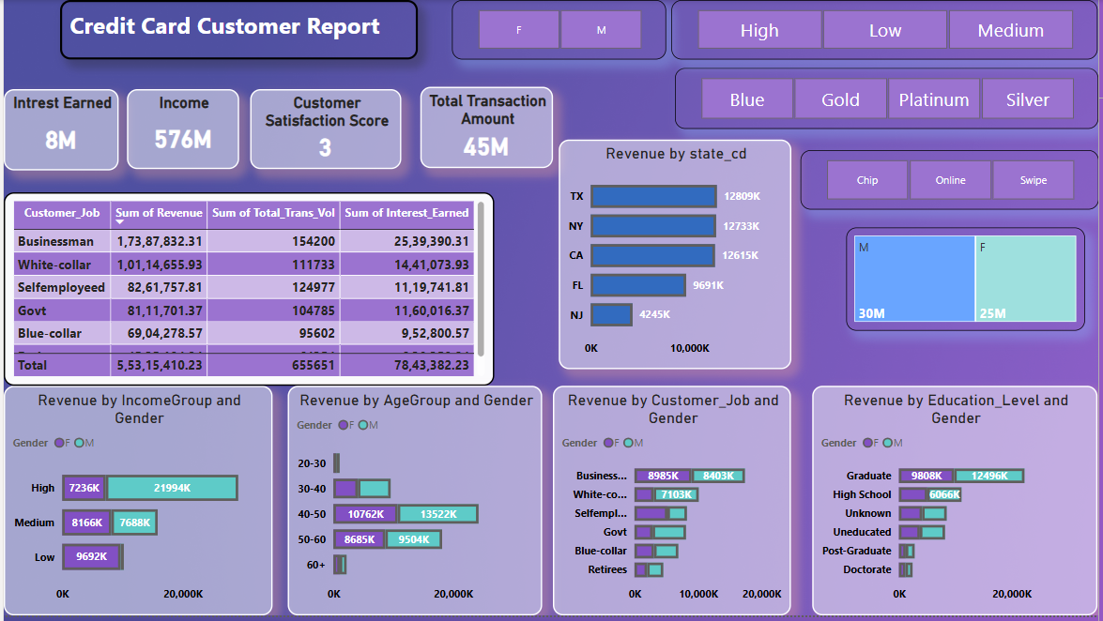
Insights:

1) Businessmen contribute the highest revenue, transactions, and interest earned.
2) TX and New York (NY) lead in state-wise revenue.
3) Males generate slightly more revenue
4) Age group 40-50 is the most active for both genders.
5) Graduate education level dominates revenue generation.

